McMillin Month of the Military Child Events
To honor our Military Families and Military Children, McMillin has the following events planned:

 | T-Shirt Design Contest | Submissions due March 15th
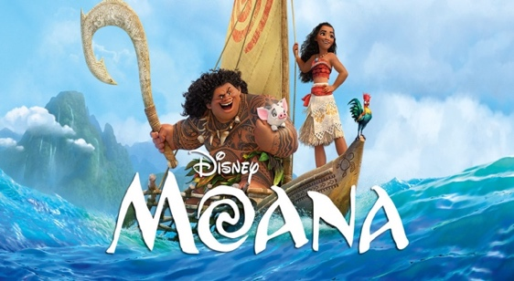 | Military Movie Night | Come join us Wednesday, April 5th from 5:00-7:00 to watch Moana. Pizza, popcorn, and water will be served. Please RSVP so that we can make sure we have enough food.  RSVP: https://tinyurl.com/zp2byz4
 | Military Month Kickoff Assembly | On Friday, April 7th at 8:45 military children will be invited to a special assembly during which time we will reveal the winner of the t-shirt design contest and pass out shirts to children.
 | Military Family Breakfast | Join us on April 14th 7:45-8:45 for donut holes and orange juice. Starting at 8:15, students will go to their classes and a representative from the Military Child Education Coalition will speak with parents about managing transitions. CVESD’s Military Family Advocate will also be at McMillin to share resources available to military families.
 | Wear Purple Day | On April 21st, wear purple in support of our military families.
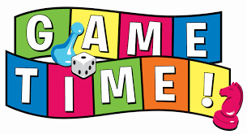 | Military Game Day | After military students eat lunch on April 28th, they will be invited into the auditorium to play games and build.

